Assignment 2
Drawing the Cartesian Plane

This assignment will test your understanding of functions, logic, and conditional statements. It will also test your ability to navigate the drawing plane.
Navigation Help
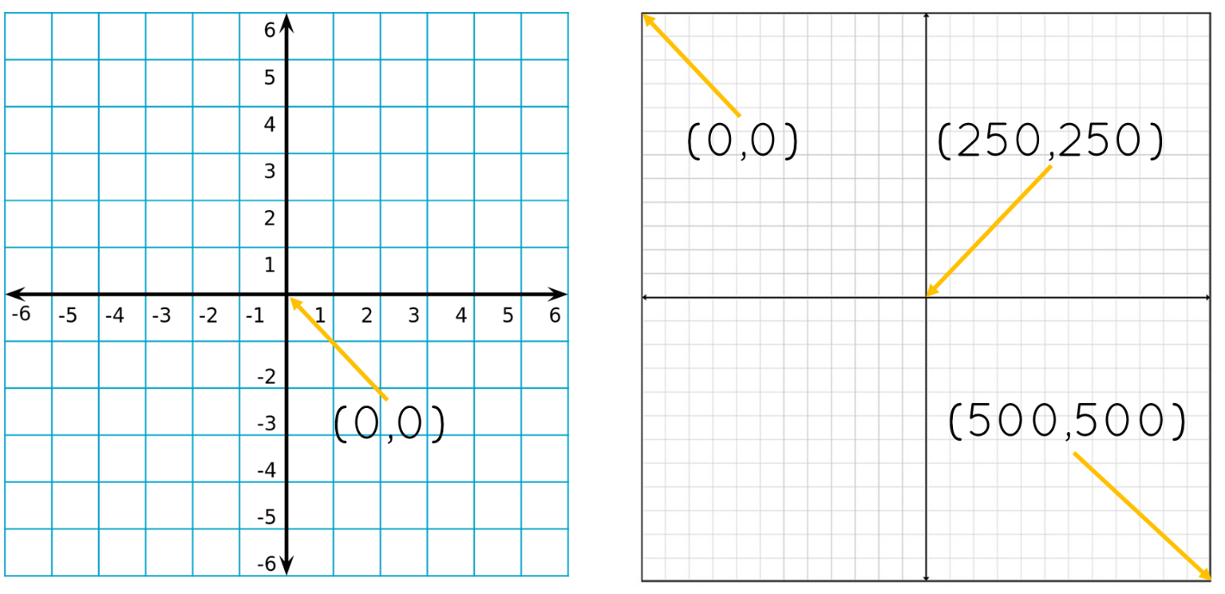
Program Requirements:
- Global variables (not defined inside a function)
  - Positioning Variables
    - center_x – integer value that stores the x position of the origin
    - center_y – integer value that stores the y position of the origin
  - Color Control
    - axis_color – value stores the color eg. black, red, blue
  - Control thickness of the line
    - axis_weight – value stores the thickness of the axis lines
  - Control axis label
  - axis_label_color – value stors the color of the axis label text.
  - axis_label = value is true of false and is used to show and hide the X and Y markers
- Two functions must be created
  - draw_axis – Responsible for drawing the axis.
  - draw_labels – Responsible for drawing the axis labels X and Y.
Test Cases:
center_x = 250 and center_y = 250
center_x = 250 and center_y = 100
center_x = 100 and center_y = 250
center_x = 100 and center_y = 250

Figure 1 - center_x = 100 and center_y = 250
Figure 2- center_x = 250 and center_y = 100
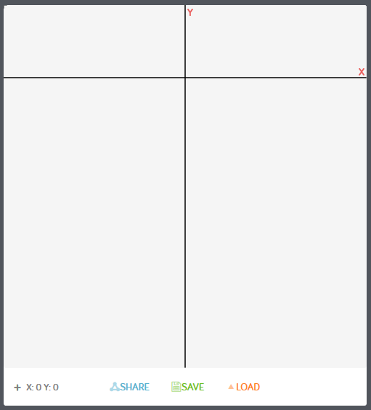
Figure 3 - center_x = 250 and center_y = 250
Figure 4 - center_x = 100 and center_y = 100
